Cairo University  
Faculty of Computers and Information



**CS251**

**Software Engineering I**

Software API

Software Design

Team Names

Month & Year

Contents

Instructions [To be removed] 3

Team 3

Document Purpose and Audience 3

System Models 3

I. System Decomposition 3

II. Class diagrams 6

Important Algorithm 7

III. Sequence diagrams 7

Class - Sequence Usage Table 9

Ownership Report 10

Policy Regarding Plagiarism: 10

References 10

Authors 10

# Team

|  |  |  |  |
| --- | --- | --- | --- |
| **ID** | **Name** | **Email** | **Mobile** |
| 20170116 | Sama Hassan AbdElsalam | Samaahassan061@gmail.com | 01151081061 |
| 20170057 | Alaa Taha Hassan | Alaataha021@gmail.com | 01002298377 |
| 20170059 | ElZahraa Mohamed Mahmoud | Elzahraam209@gmail.com | 01067580764 |
| 20170133 | Doha Khaled Hussien | Dohakhaled98.dk@gmail.com | 01112242467 |

# Document Purpose and Audience

Purpose : This document describe the diagrams for Designing API for social media network.

Audience: Software Developers ,CEO , Analyst and the client

System Models

## I. System Decomposition

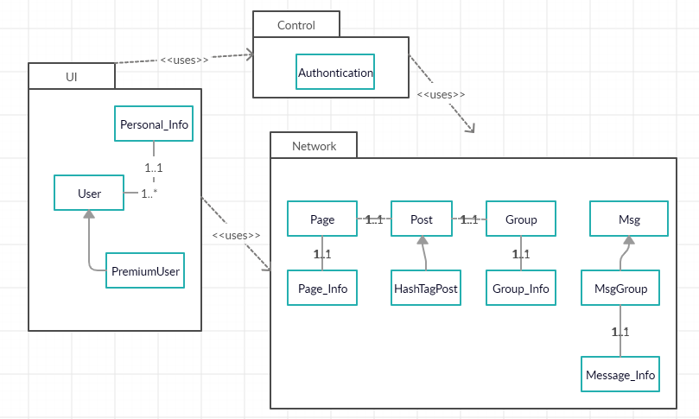

## 

## II. Class diagrams

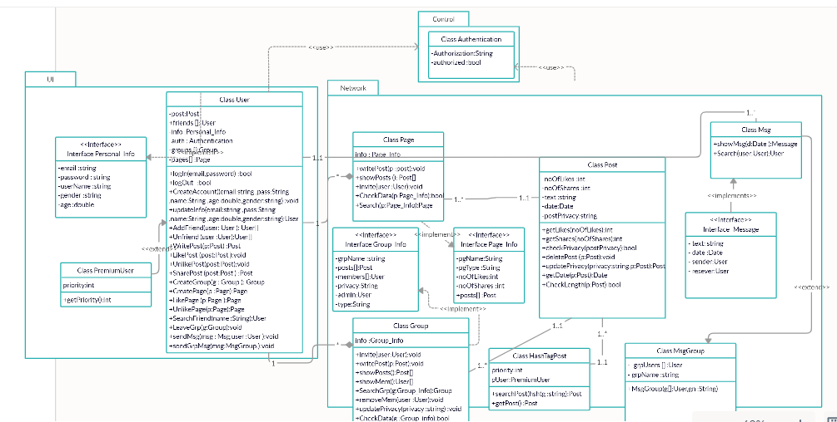

Link if the Picture is un clear : <https://app.creately.com/diagram/2yOkCvDHu2f/edit>

| **Class ID** | **Class Name** | **Subsystem ID** | **Description & Responsibility** |
| --- | --- | --- | --- |
| 1 | User | 1 | Contains all functions that user can do in the system |
| 2 | PremiumUser | 1 | Contains all info required for premium user |
| 3 | Personal_Info | 1 | Contains all information for user |
| 4 | Group | 2 | Contains the functions that user can do with the group |
| 5 | Group_info | 2 | Contains all information for group |
| 6 | Page | 2 | Contains functions that required for user to deal with Page |
| 7 | Page_Info | 2 | Contains all information for Page |
| 8 | Msg | 2 | This class communicated between user and his friend to chat with each other |
| 9 | MsgGroup | 2 | This class allow user to create chat group and send message to them |
| 10 | Post | 2 | Class is responsible for managing any post the user writes |
| 11 | HashTagPost | 2 | Class manges the # posts and how to find a specific post |
| 12 | Authentication | 3 | The class that controls the correctness of every input . |

## III. Sequence diagrams

2.1 SN_1 Register

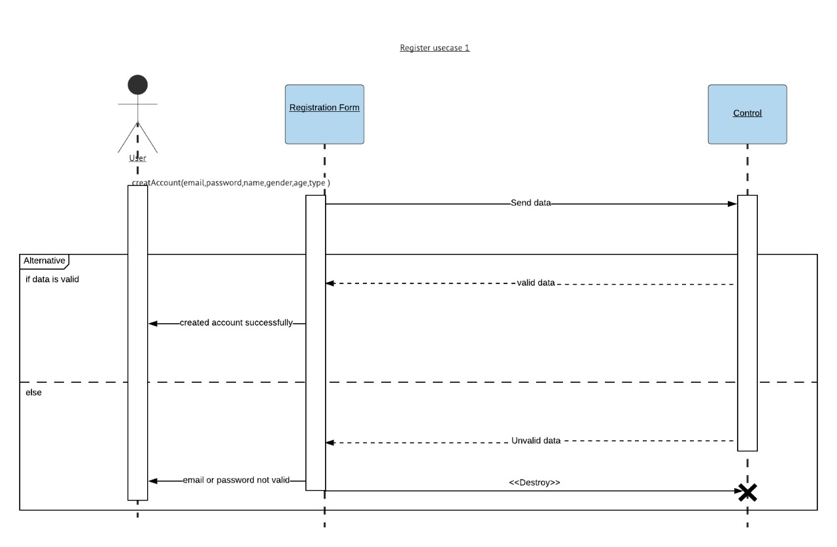

2.2 SN_2 Add friend

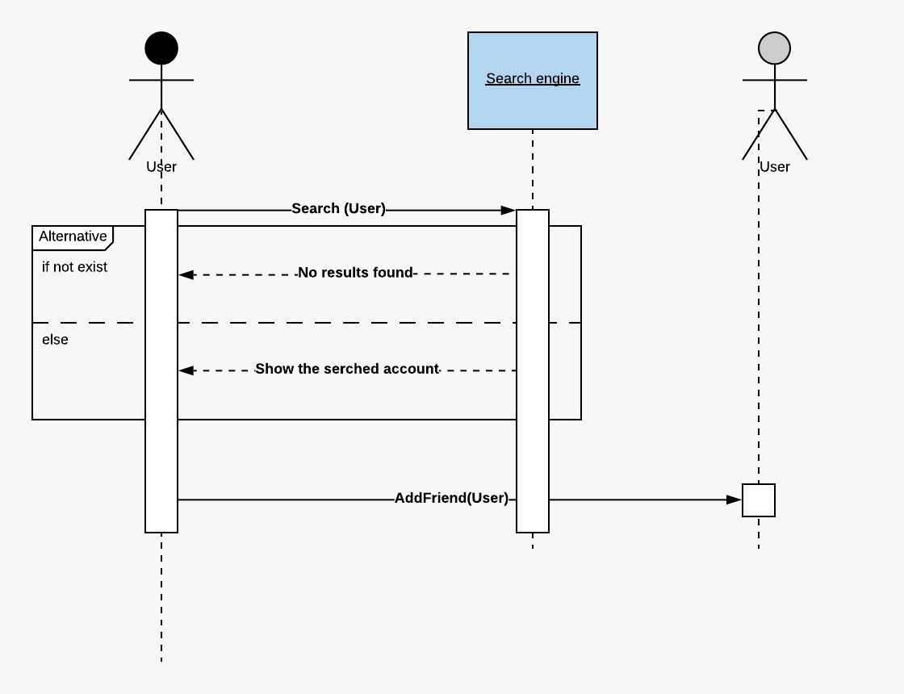

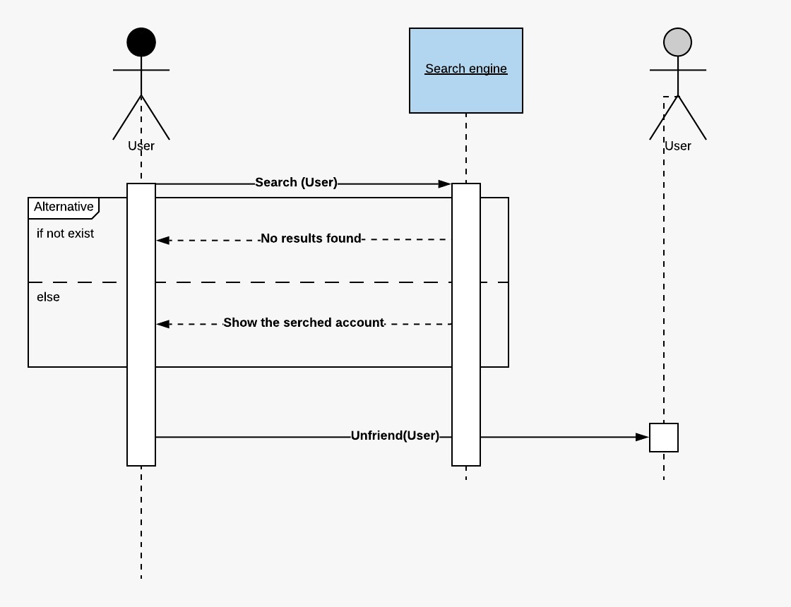

2.3 SN_3 Posts

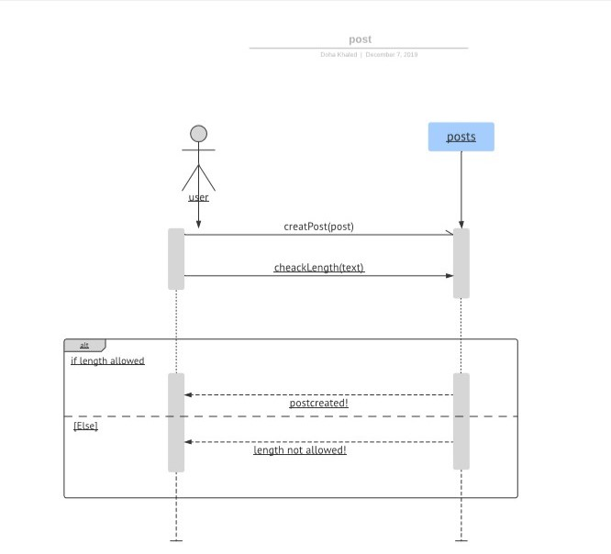

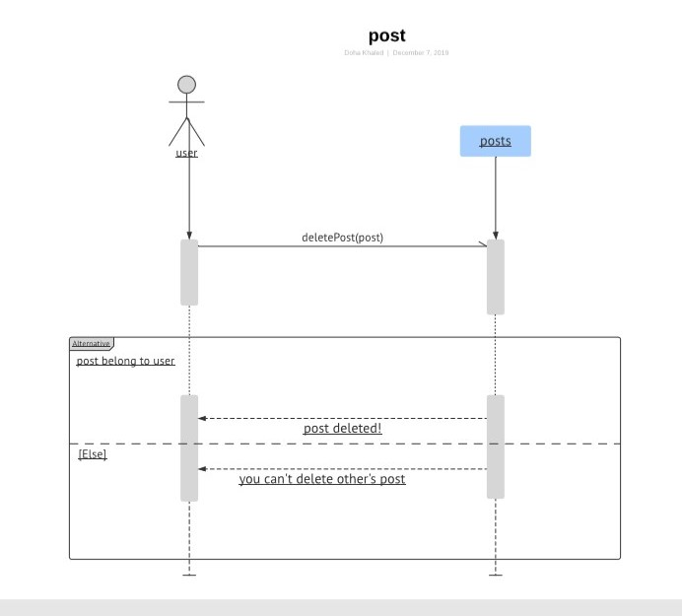

2.4 SN_4 hash tag

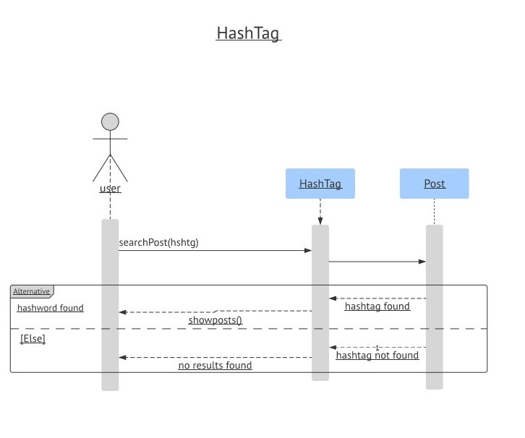

2.5 SN_5 Create a page

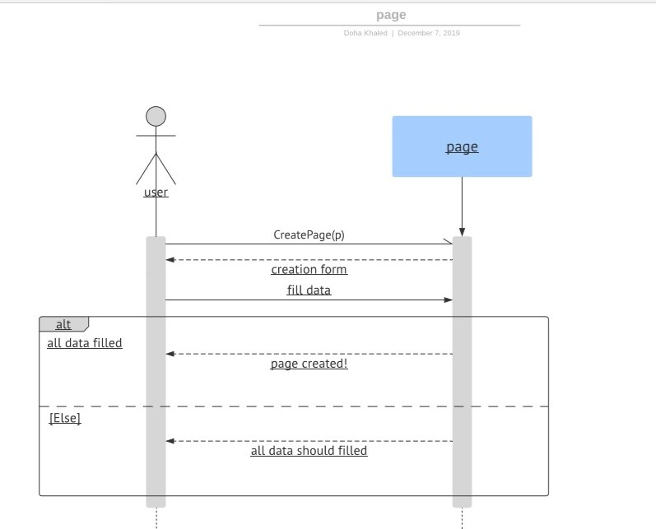

### 

### 2.6 SN_6 Create a group

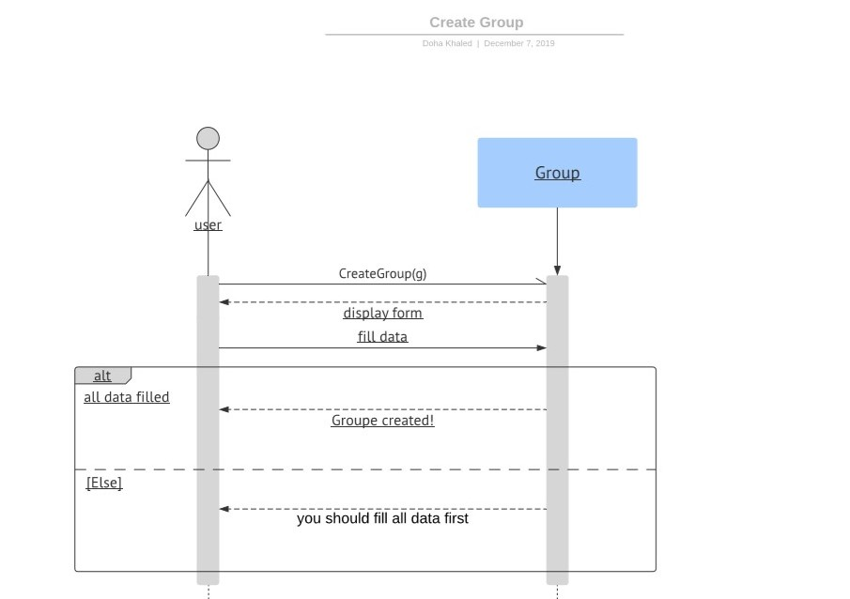

2.7 SN_7 send message

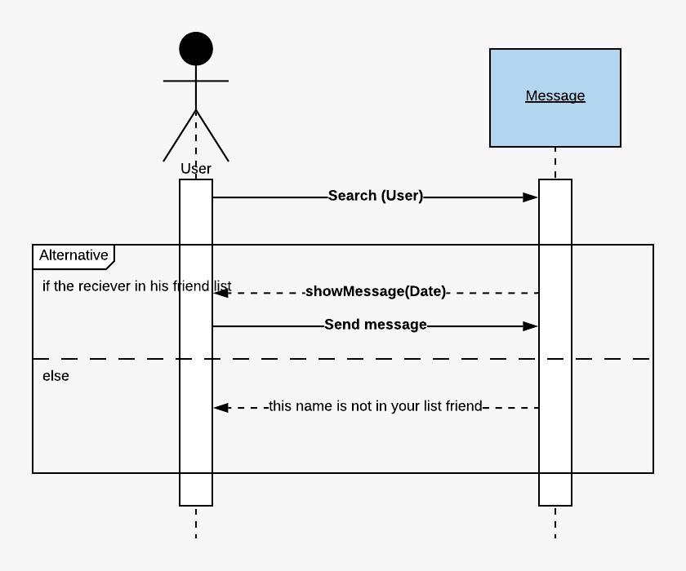

2.8 SN_8 Send message to group of friends

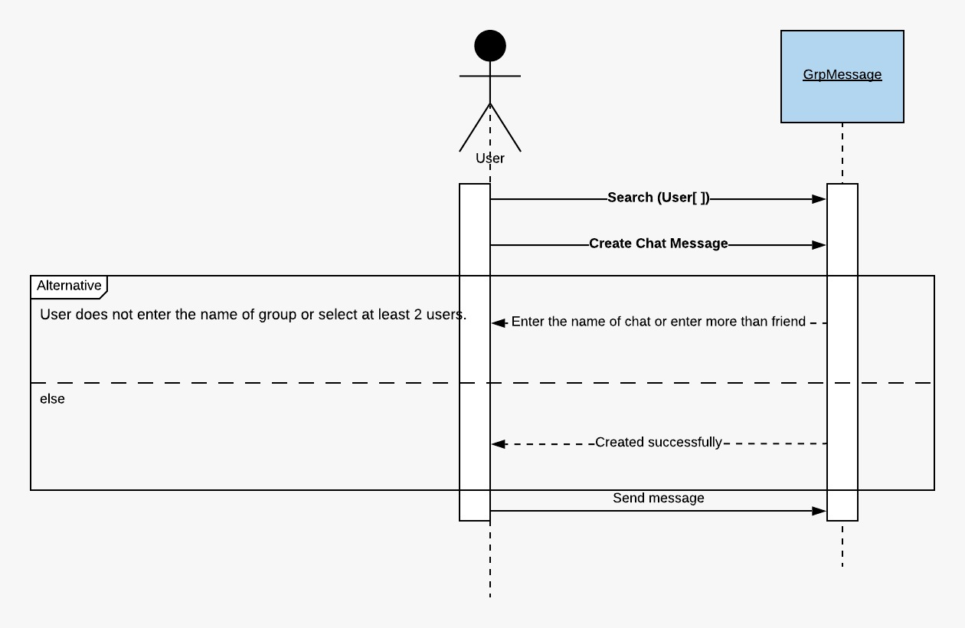

### Class - Sequence Usage Table

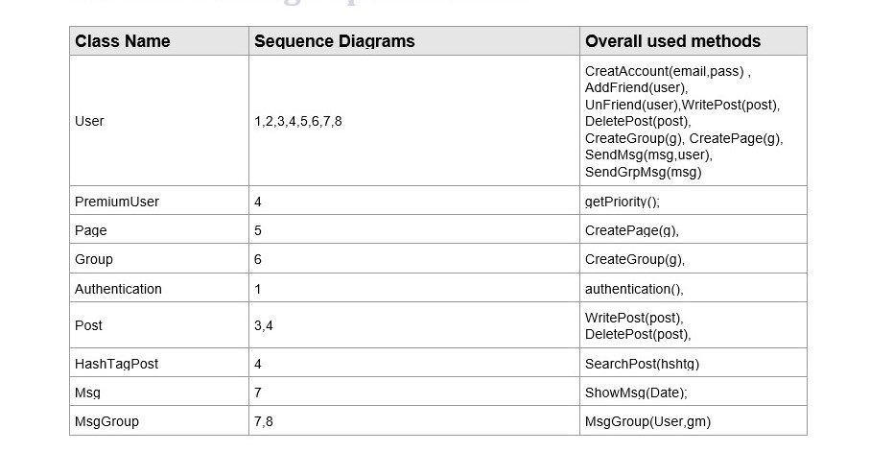

# Ownership Report

|  |  |
| --- | --- |
| **Item** | **Owners** |
| Decomposition System | *Sama Hassan* |
| Class Diagram | *Alaa Taha* |
| Sequence Diagram (3,4,5,6) | *Doha Khaled* |
| Sequence Diagram (1,2,7,8) | *ElZahraa mohamed* |